Business Requirements Document (BRD)

Project: Supply Forecasting and Planning Of Jaguar and Land Rover
Project Overview
The project will focus on the proposal and application of the appropriate demand and supply forecasting models of the Jaguar and land Rover vehicles using historic data. The information would be in the form of Car Name, Model Name, Distribution Process, Year, Financial Year, quarterly sales (Q1, Q2, Q3, Q4) and the total annual sales which would be used to establish the sales trends, seasonal sales and demand of that model. With this information, the project is likely to come up with some credible predictions which could be applied in inventory control, production schedules and strategic decisions to ensure that the available resources are well distributed in terms of models and distribution channels.

Objectives
- Examine previous sales and distribution records of Jaguar and Land Rover, Car Name, Model Name, Distribution Process, Year, Financial year, quarterly sales (Q1-Q3), and total sales.
- Optimize inventory and distribution through identification of high demand and low demand models and tracking of the wholesale vs retail discrepancies.
- Assist in production planning on the basis of trend analysis, seasonal patterns, and model level demand forecasting.
- Enhance the sales plan with the best performing models, contribution to sale in the market and fluctuating and resilient sales.
- Deliver practical information via visualizations to manage supply and market demands to improve operational performance.
History
Tata Motors (previously called Tata Engineering and Locomotive Company (TELCO)) was started as a company in 1945 to produce locomotives and eventually received a commercial and passenger car segment. The company got known globally when it ventured into passenger car market featuring models such as Tata Indica. Another turning point was made in 2008 when Tata Motors purchased the luxury British automaker brand Jaguar and Land Rover of Ford at the price of 2.3 billion dollars. Jaguar Land Rover (JLR) was losing money at the time, and Tata Motors had confidence in the management in the country, UK, investing in the research, technology, and new models. JLR became profitable within several years having such popular models as Range Rover Evoque and Jaguar F-Type. This has allowed Tata Motors to acquire global acknowledgement, cutting edge automotive technology and a better presence in the luxury automobile market and JLR has become a major contributor to the revenues of Tata Motors today.

Data Source & Description
Data Source : - https://www.tatamotors.com/volumes/
Key fields:
Car Name, Model Name, Distribution process_wholesale, Financial, Q1 _wholesale, Q2_wholesale, Q3_wholesale, Q4_wholesale, Total_wholesale, Distribution process_retail, Q1 _retail, Q2_retail, Q3_retail, Q4_retail, Total_retail

Data Cleaning & Transformation
Data Exploration:-
Number of rows and columns:- (463, 16)

Data Types:-
Column Dtype
--- ------ -------------- -----
0 Car Name object
1 Model Name object
2 Distribution process_wholesale object
3 Year object
4 Financial Year object
5 Q1 _wholesale object
6 Q2_wholesale object
7 Q3_wholesale object
8 Q4_wholesale object
9 Total_wholesale object
10 Distribution process_retail object
11 Q1 _retail float64
12 Q2_retail float64
13 Q3_retail float64
14 Q4_retail float64
15 Total_retail float64

Data Type Correction
During the initial review, several columns were not stored in the appropriate data types. This affected the accuracy of summary statistics and limited the ability to perform analysis. The data types were corrected based on the nature of each variable.

Column Dtype
--- ------ -------------- -----
0 Car Name object
1 Model Name object
2 Distribution process_wholesale object
3 Year object
4 Financial Year object
5 Q1 _wholesale float64
6 Q2_wholesale float64
7 Q3_wholesale float64
8 Q4_wholesale float64
9 Total_wholesale float64
10 Distribution process_retail object
11 Q1 _retail float64
12 Q2_retail float64
13 Q3_retail float64
14 Q4_retail float64
15 Total_retail float64

Duplicate Records Check:-
A check for duplicate entries was performed to ensure data integrity. After reviewing all rows, no duplicate records were found in the dataset. This confirms that each observation is unique and the dataset does not require any deduplication steps.
Number of duplicate:- 0

Missing Value Check
Car Name 0
Model Name 0
Distribution process_wholesale 214
Year 0
Financial Year 0
Q1 _wholesale 217
Q2_wholesale 231
Q3_wholesale 230
Q4_wholesale 231
Total_wholesale 215
Distribution process_retail 235
Q1 _retail 238
Q2_retail 238
Q3_retail 237
Q4_retail 235
Total_retail 235

For variables containing missing values, appropriate imputation techniques were applied to maintain data consistency. Numerical and float-type variables were imputed using their mean values to preserve the overall distribution of the data. Categorical variables were imputed using their mode, ensuring that the most frequent category was retained.

Data Transformation
df['Year'] = df['Year'].str[:4].astype(int)
Year column originally contained values in an incorrect or extended string format. To standardize it, only the first four characters were extracted, and the column was converted into an integer data type

Cleaning Extra Spaces in the ‘Car Name’ Column
The Car Name column contained leading, trailing and multiple unnecessary spaces between words. To standardize the text format, extra spaces were removed using string operations.
Outlier Detection and Removal Using Z-Score
To identify extreme values in the numerical variables, the Z-score method was applied. Z-scores were calculated for all numeric columns, and a threshold value of 3 was used to flag potential outliers. Any data point with a Z-score greater than 3 (in absolute terms) was considered an outlier. After detecting them, rows containing these extreme values were removed from the dataset.

Encoding Categorical Variables Using Label Encoding
The dataset contained several categorical columns that needed to be converted into numerical form for further analysis and machine learning workflows. Label Encoding was applied to each categorical variable, where every unique category was assigned an integer value. A separate encoder was created and stored for each column to maintain consistency during future transformations. This step ensured that all categorical features were properly encoded and ready for model building.

Summary Statistics
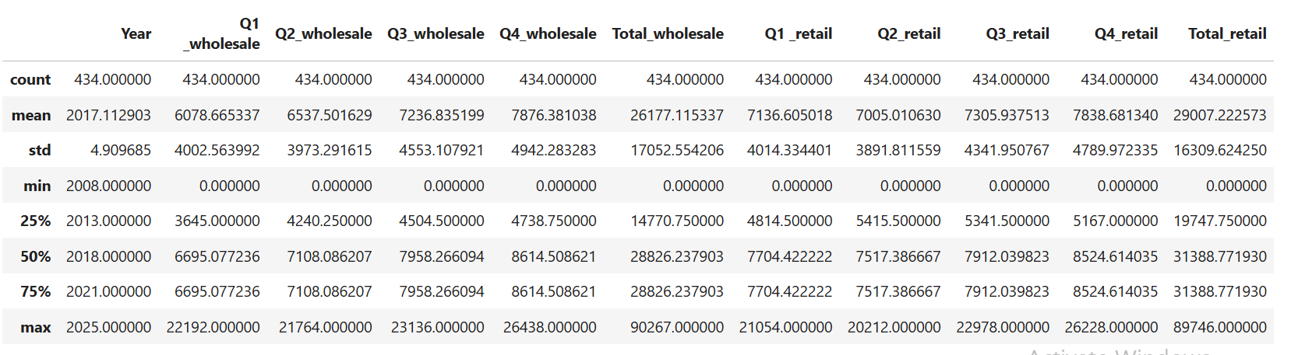

Analysis & Visualizations
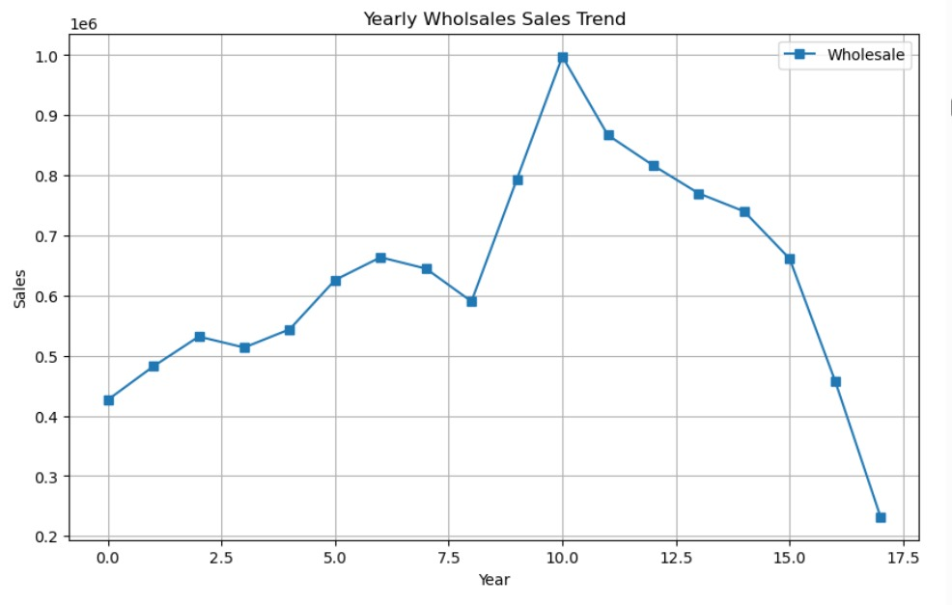

This chart illustrates the Annual Trend of Wholesale Sales in the course of time (approximately 17 years).
Sales were approximately 4.3 lakh at the beginning and it was growing steadily in the first few years. The peak performance of the sales was experienced in the 10th year when it stood at approximately 10 lakh.
Following this high, sales started to go down steadily, plummeting after the 15th year and registering an all-time low (approximately 2.3 lakh) at the end of the period.
With a basic explanation, the business had had a smooth rise in sales initially, followed by a high boom and consequent slow but sharp decline, implying that once sales performance had been successful, there was a sharp decline in sales performance later in the years.

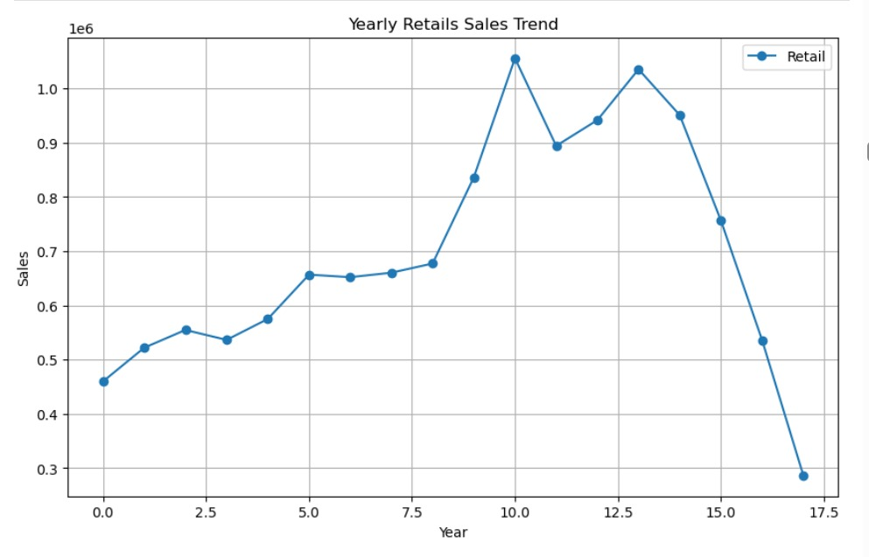
The changes in retail sales throughout the years have been displayed in this chart. During the first few years, sales were low but it has been rising gradually every year. The peak in sales was experienced between the 10 th year and 1011 th year as there was a robust growth period. Then, there was a slight fluctuation in its sales, as it rose and fell, but it was still big until approximately the 14th year. But after the 15 th year, sales declined severely, which reached its lowest point in the 17 th year. In general, the chart indicates that there was a long-term growth with an abrupt decrease in the last years.

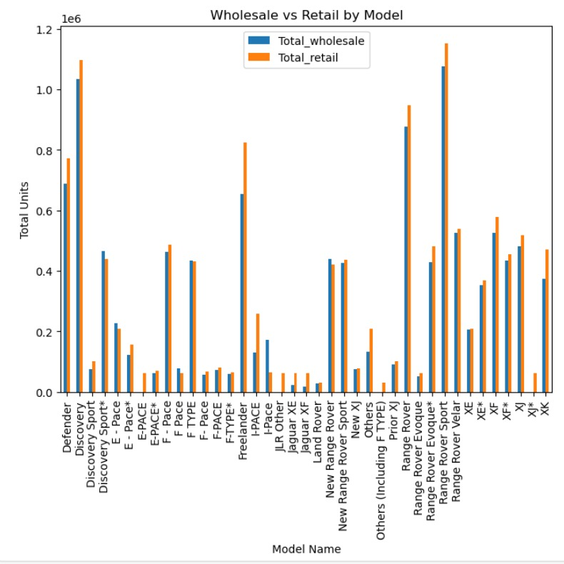
This graph draws comparison between wholesale units and retail units of various car models. Each model has a blue bar that represents the number of units sold wholesale (to dealers), and an orange bar that represents the number of units sold retail (to customers). In most of its models, such as Discovery, Range Rover, Range Rover Sport and Range Rover Evoque, the retail sales on the models are a little more than the wholesale implying that more cars found their way to the actual customers. Certain models, like the Defender and the New Range Rover Sport have more wholesale figures, this could mean that there are still dealers who have not sold the unit. In general, the chart indicates that the most trending models have high wholesale and retail sales, whereas the less popular models have significantly smaller bars. This will enable us to know the models that are doing well in the market, and the ones with low demand.

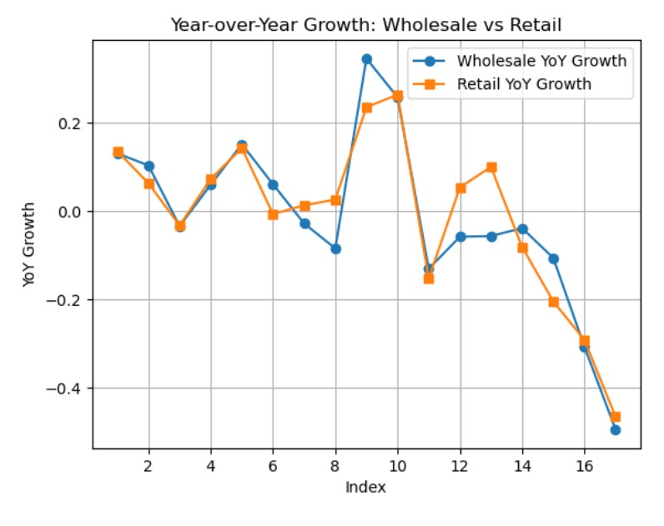
This chart will present the Year-over-Year (YoY) Growth comparison of the Wholesale and Retail sales between various time periods (which will be presented in the index number on the x-axis).
Wholesale YoY Growth and Retail YoY Growth are the blue and orange lines respectively. The two lines travel closely thus indicating that Wholesale and retail growth tend to have a similar trend.
Initially, both exhibit small positive changes followed by fluctuation up and down occasionally increasing followed by slight decrease and vice versa. In the centre of the chart, the two categories display an intensive growth, with the highest growth of wholesale (around 0.35). Subsequently, the growth levels begin to fall and as the growth levels become negative (approximately, -0.45) towards the end, meaning that the sales decrease in comparison to the past year.
Simply put, the growth was very strong in the initial stages of both wholesale and retail sales but there were fluctuations, some good and some bad, and then at the peak of the growth, it became quite high, and then there was a sharp decline in the growth.

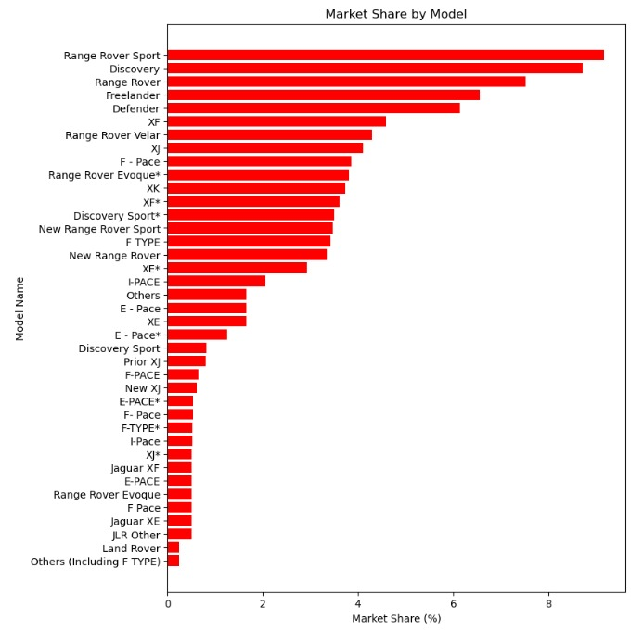
The following chart indicates the market share of various car models. The red bar is the longer the more popular the model will be in the market. Compared to the rest, Range Rover sport has the largest market share, closely followed by Discovery and Range Rover meaning that these models are the most favored by the customers. Other models such as Freelander, Defender, XF, and Range Rover Velar also possess a good share although not as high as the top three. The market share decreases further into the chart indicating that these models are not as popular. The lowest models like F-TYPE, Jaguar XE, and Land Rover, among others, have the least market share. On the whole, the chart shows that the dominance in the market is held by Range Rover and Discovery models with a significant percentage of sales of many other models being very low.

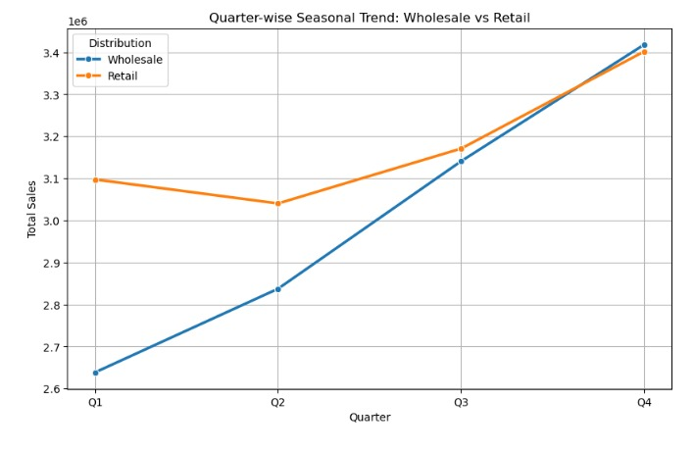
The graph indicates the seasonal pattern of Wholesale and Retail sales on a quarterly basis. Retail sales begin at a higher point of Q1 at approximately 3.1 million, it slightly drops in Q2, and then increases in Q3 and Q4 to approximately 3.45 million. The sales of wholesale commences at a low of about 2.64 million in Q1 but steadily grows quarter after quarter. The increase between Q2 and Q3 is huge and by Q4 the wholesale sales have increased to around 3.46 million, exceeding retail sales. In general, the data shows that retail sales are comparatively steady with a slight drop in Q2, but at the same time, the growth of the wholesale sales is consistent and high over the year as compared to the retail one, which probably can be attributed to the seasonal demand peaks in the last quarter.

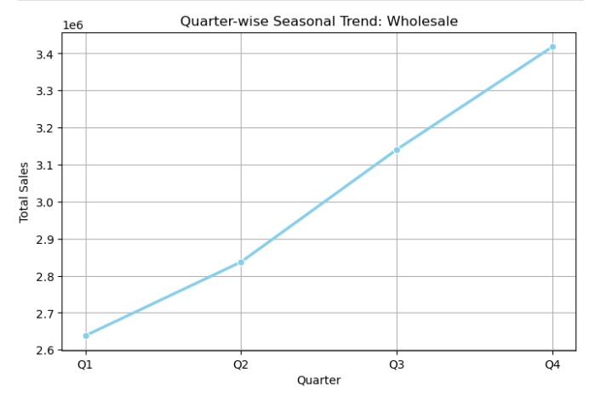
This graph depicts the sales on wholesale per quarter of the year. The lowest sales occur in the first quarter (Q1). The sales then grow during Q2 and furthermore during Q3. The sales are at its peak in the fourth quarter (Q4). On the whole, the chart indicates that the growth of wholesale sales is rather constant throughout the period between the start of the year and the end.

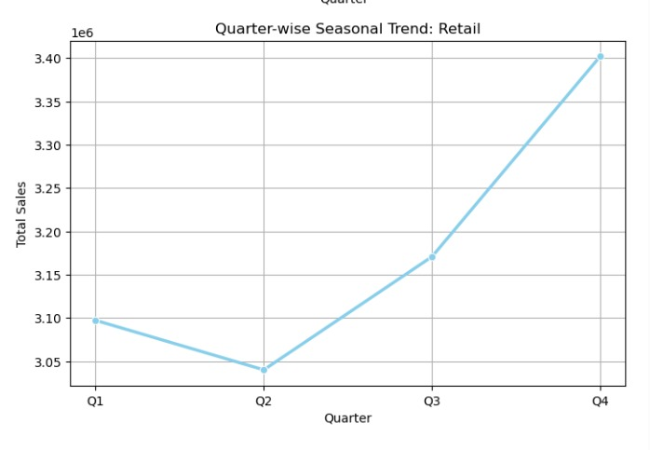
This graph is used to indicate the retail sales at each quarter. The retail sales begin at the moderate level in Q1 and gradually decline in Q2. Then the sales again grow further in Q3 and peak in Q4. This implies that the retail sales is likely to experience an increase in the second half of the year and Q4 is likely to be the best. Generally, the trend indicates that the customers have the highest buying activity in the late years of the year.

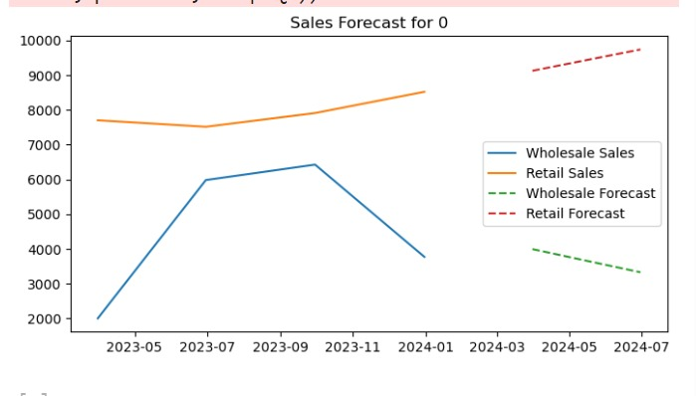
This chart will indicate the sales trend and projection of the sales (both wholesale and retail) between 2023 and mid-2024.
Based on the graph, we are able to view that the level of wholesale sales (blue line) initially stood at a low point of approximately 20,000 in May 2023, and then shot up and peaked at approximately 64,000 in September 2023. Subsequently, the wholesale sales declined steadily and reached approximately 3800 in the first months of 2024. The forecast (green dashed line) is that the decrease in wholesale sales will be further continued in the coming few months.
Retail sales (orange line) in its turn began at a much higher point (approximately 7,600) and remained relatively steady with a slight decline mid-year and then rising slowly to 8,500 towards the end of 2023. The prognosis (red broken line) indicates that the growth of retail sales will continue to increase (slightly) in 2024.
Simply put wholesale sales are declining, retail sales are steadily increasing and are expected to do better in months to come.
This output is a result of an analysis of supply in which the discrepancy between wholesale and retail figures was computed to determine which models are over supplied and which are under supplied.

Top Oversupplied Models section gives the list of models whose supply (wholesale) is higher than the retail demand. To illustrate, the oversupply of Discovery Sport is the most with a difference of approximately 46,072, next is Models F -pace, E – Pace and F-Pace:which also have a positive difference, i.e. additional stock is available in the market.
The Top Undersupplied Models category presents the models with inferior supply as compared to retail demand, i.e. there is inadequacy. Range Rover Sport also emerges again with negative value (-49,043) indicating the highest shortage and then Model Discovery, Range Rover and Defender emerge with their negative value and it indicates that the demand is higher than the supply.

Simply put, the analysis will be used to determine the models of products that are overstocked (oversupplied) and the one that are in shortage (undersupplied), enabling the company to better balance production and inventory.

Forecasting
Annual forecasting

By Car Type

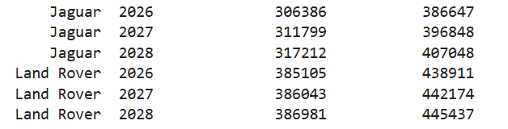

By Model Type

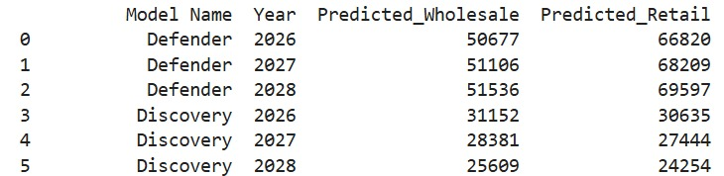

Quarterly forecasting
By Car Type
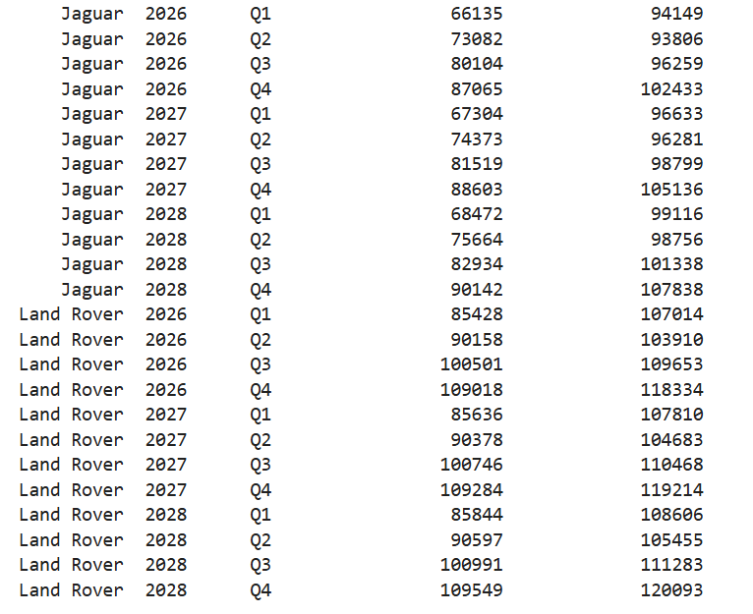

By Model Type
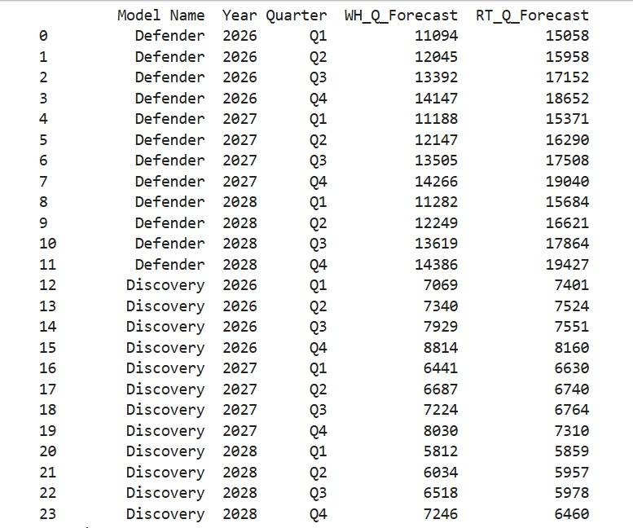

Conclusion & Recommendations
The sales analysis indicates that Jaguar and Land Rover enjoyed tremendous growth over several years and during the 10th year, the sales of the two brands hit the peak and then had a precipitous downfall in wholesale and retail sales. High selling products such as Range Rover sport, Discovery, and Range Rover remain at the top of the market whilst other product models have low demand.
The trend of wholesale and retail is shifting the same way however the trend of the recent data is that the wholesale is going down and retail is showing slight increase, so there is a need to control the production and avoid overstocking. The supply gap analysis also indicates some models are overstocked whereas others are undersupplied, which indicates the necessity in aligning the demand and supply.
All in all, the company has to pay attention to high demand models, eliminating excess stock, enhancing forecasts and its sales strategy to get out of the negative trend

